Name: Priya lakra

Roll No: CS21M047

XQUERY

1. **List of the names of vendors who are located in the state “Chennai”.**

Query:

for $x in APPLICATION/ECOMMERCE/Vendor

where contains($x//City,"Chennai")

return $x/Name

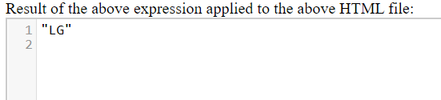

2. Description of the complaint which is being handled by the agent “HTR 123”

Query:

for $x in APPLICATION/ECOMMERCE/Customer/Complaint,

    $y in APPLICATION/ECOMMERCE/HelpLine

    where $x/ComplaintNumber=$y/ComplaintNumber and contains($y/Agent,"HTR 123")

return $x/Description

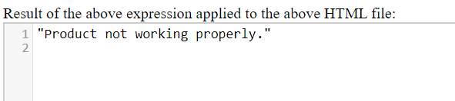

3. Name of customer who have 3 or more products in his cart.

Query:

for $x in APPLICATION/ECOMMERCE/Customer

let $y := $x//Cart/NumberofItems

where $y >=3

return $x//UserName

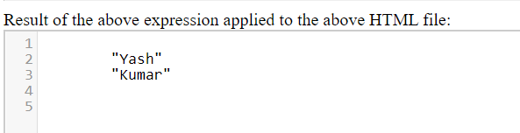

4. List of all BillNumber whose total amount more than 10000

for $x in APPLICATION/ECOMMERCE/Customer/Order/Bill

let $y:= $x/Total

where $y>10000

return $x/BillNumber

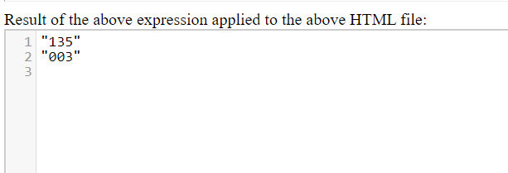

XPATH

1. Print all the customer details who are using ecommerce application.

/APPLICATION/ECOMMERCE/CUSTOMER/*

